**Agile methodologies**

Why Agile?

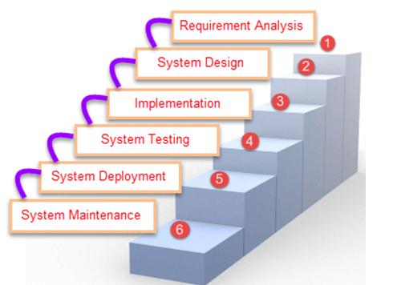

Here, client will check the software once deployment or release is done. So they involved at the end of project and don’t know what is going on project work during the entire year. That’s why agile comes into picture.

Below are the list of different SDLC phases as

1. Requirement analysis-

In this phase, details requirements of software are to be taken by the client.

1. System design-

It decides the programming language such as java or .net, database like MYSQL or oracle, then front end tool, etc.

1. Implementation-

In this, actual project development is to be started.

1. System testing-

It performs the testing of software, also check whether the software is designed as per client requirement or not.

1. System deployment-

It will deploy the application on respective environments e.g. tomcat server.

1. System maintenance-

Once you deploy the application on server, later point you might be add or changes the requirement as per client request.

What is Agile?

AGILE methodology is a practice that promotes continuous iteration of development and testing throughout the software development lifecycle of the project.

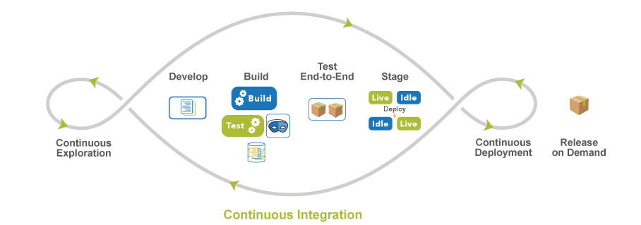

In the Agile model, both development and testing activities are concurrent.

Scrum-

SCRUM is an agile development method which concentrates specifically on how to manage tasks within a team-based development environment.

Scrum Master

Master is responsible for setting up the team, sprint meeting and removes obstacles to progress

Product owner (BA)

The Product Owner creates product backlog, prioritizes the backlog and is responsible for the delivery of the functionality at each iteration.

Scrum Team

Team manages its own work and organizes the work to complete the sprint or cycle.

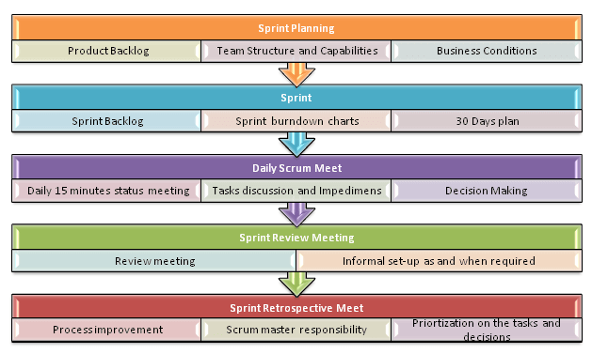

Sprint planning-

The team discusses top priority user stories and decides what can be delivered in the sprint.

Product Backlog-

The total number of requirements is to be completed for each release.

It should be maintained and prioritized by Product Owner. Team can also request for a new requirement addition or modification or deletion

Sprint- it has time limit in which work has to be finished. (15, 21, 30 days).

Sprint backlog-

The total number of requirements is to be done during the sprint.

Sprint burn down charts-

Burn down chart shows how much work is remaining to be done in the project.

Sprint burn up charts-

Burn up chart shows how much work has been completed.

Sprint review meeting-

The sprint review meeting focuses on what was built during the current Sprint.

Who is involved into sprint review meeting?

Product owner, scrum master and development teams.

Other stakeholders give feedback on the product that was built.

Sprint retrospective meet-

The sprint retrospective meeting is focused on improving future sprints in terms of  
the process.

Sprint retrospective meeting involves the scrum master and the development team.  
Product owner is optional attendee.

The scrum master and development team give feedback on how the team can improve the process as a whole.

Three questions asked in daily scrum meeting.

* What did you do yesterday?
* What will you do today?
* Are there any blockers or impediments preventing you from doing your work?